mosaicplot(WALMART1$COOKIES~WALMART1$MILK, xlab = "Cookies", ylab = "Milk")

- We focus on the bottom right square, as it includes the purchase of both items.

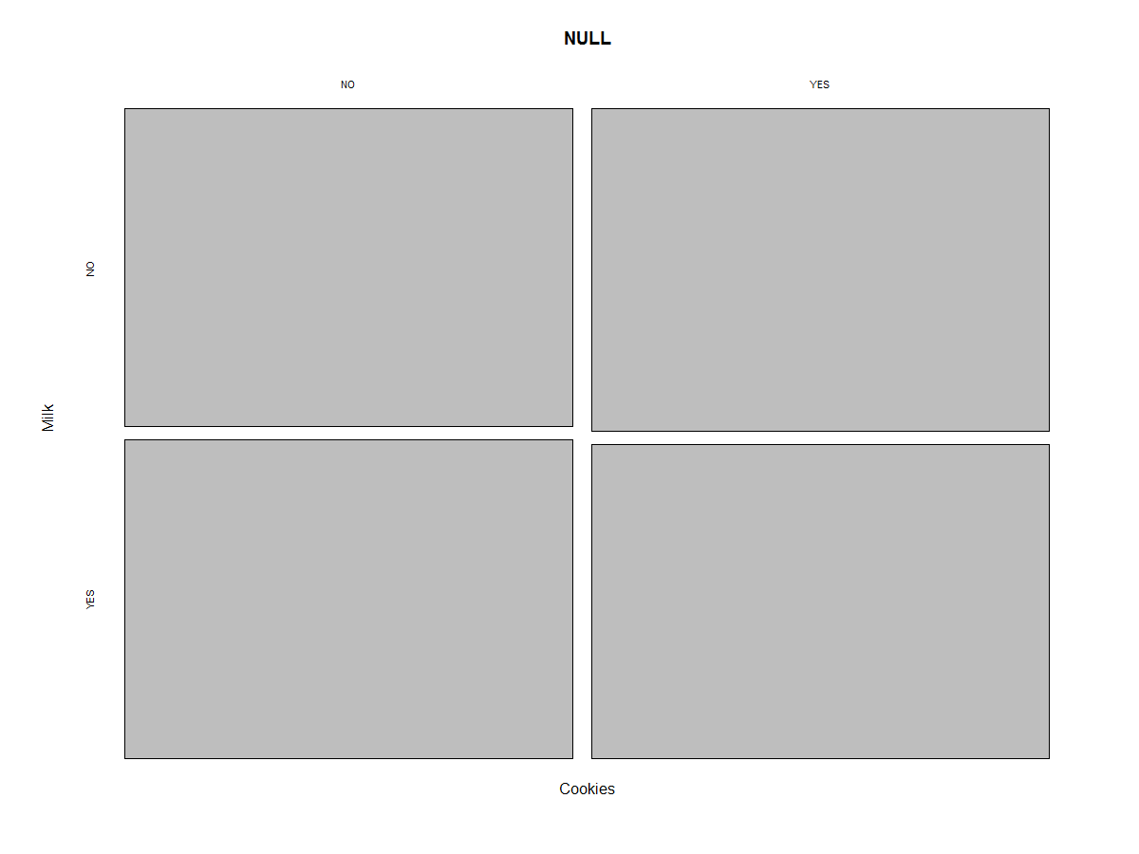

* > Cookies.data <- WALMART$COOKIES
* > Milk.data <- WALMART$MILK
* > mean.cookies <- mean(Cookies.data)
* > mean.milk <- mean(Milk.data)
* > len.cookies <- length(Cookies.data)
* > len.milk <- length(Milk.data)
* > sd.cookies <- sd(Cookies.data)
* > sd.milk <- sd(Milk.data)
* > sd.cookies.milk <- sqrt(sd.cookies^2/len.cookies + sd.milk^2/len.milk)
* > zeta <- (mean.cookies - mean.milk) / sd.cookies.milk
* > zeta
* [1] 1.230354
* > p <- 1 - pnorm(zeta)
* > p
* [1] 0.1092823
* > PermutationTestSecond::Permutation(WALMART, "COOKIES", "MILK", 1000, "1", "0")
* [1] 0.197
* >PermutationTestSecond::Permutation(WALMART, "COFFEE", "SUGAR", 1000, "1", "0")
* [1] 0.01
* With 1000 permutation tests, the p value seems to argue that coffee buyers stick with sugar.
* > PermutationTestSecond::Permutation(WALMART, "CHICKEN", "SALT", 1000, "1", "0")
* [1] 0.392
* > PermutationTestSecond::Permutation(WALMART, "TEA", "HONEY", 1000, "1", "0")
* [1] 0.136
* > PermutationTestSecond::Permutation(WALMART, "FISH", "SALT", 1000, "1", "0")
* [1] 0.264
* > PermutationTestSecond::Permutation(WALMART, "COOKIES", "SUGAR", 1000, "1", "0")
* [1] 0.097
* > PermutationTestSecond::Permutation(WALMART, "STEAK", "BREAD", 1000, "1", "0")
* [1] 0.212
* > PermutationTestSecond::Permutation(WALMART, "STEAK", "CHICKEN", 1000, "1", "0")
* [1] 0.416
* > PermutationTestSecond::Permutation(WALMART, "FISH", "CHICKEN", 1000, "1", "0")
* [1] 0.248

Stock up on sugar and coffee! Advertise them both together as they have a p value ranging near 1 percent!